Use-Case Realization Report
Sales Order Management

Issue <1.0>
Revision History
Date | Issue | Description | Author
09 May 2011 | 1.0 | First Issue | Junaith

Table of Contents
1. Brief Description 4
2. Flow of Events 4
3. Interaction Diagrams 4
3.1 Collaboration Diagram for Sales Order Management 4
4. Participating Objects 4
4.1 Sales Staff 5

4.2 Sales Order 5

4.3 Form Login 5

4.4 Form Create Sales Order 5

4.5 Form View Sales Order 5
5. Class Diagrams 5
6. Derived Requirements 5

Use-Case Realization Report
Sales Order Management

Brief Description
The use case enables the sales staff to do the CRUD functions.
They are :
- Creating a Sales Order
- Updating a Sales Order
- Deleting a Sales Order
- Viewing Sales Orders

Flow of Events
The standard flow of events for this use case and any exception are described in the following subsections. The events are described in terms of Actors and Analysis Objects.

Standard Flow
This use case provides the user interface related functionality that will be provided to the Sales Staff, as follows:

Log-In
To commence using the system, the Sales Staff is required to log-in as follows:
- The Sales Staff is required to enter a valid password into the Home Page.
- The system will check that the entered password is valid.
- If the password is invalid then the caption “Invalid Password” will be highlighted on the Home Page.
- If the password is valid (ie: the Sales Staff has successfully logged-in), then the following will occur:
- The welcome message will be displayed.
- The Sales Staff will be given access to the required functionality according to the authorization.

User Functions
If the Sales Staff logs-in successfully, then the following functions are available to the Sales Staff:
- The Sales Staff will be able to Create new Sales Orders as follows:
- There will be text boxes to key in the necessary details to create new sales orders.
- While the necessary details are being keyed in and if there are any error e.g. (a text being entered instead of numerals) an error message will be displayed.
- Once the Create Sales Order button is clicked a new Sales Order will be created.
- The Sales Staff will be able to View the Sales Order Created, and will also be able to Update or Delete the Sales Orders as follows:
- The list of Sales Orders created will be displayed on the ViewSalesOrder page.
- The Sales Staff can see the various orders, their status and details on this page.
- The Sales Staff can Update a Sales Order if he needs to.
  - The Sales Staff click the hyperlink to update a Sales Order.
  - The necessary changes are keyed in the relevant fields and validated meanwhile.
  - Once the Update Sales Order button is clicked the changes are updated.
- The Sales Staff can Delete a Sales Order if he needs to.
  - The Sales Staff click the hyperlink to Delete a Sales Order.
  - On the Reason for Deletion Text box the reason for Deleting the order is entered.
  - Once the Delete Order button is clicked the Sales Order is marked Deleted.

Log-Out
- The Sales Staff will terminate use of the Sales Order Management function (ie: log-out) by pressing a button with the caption “Log Out”. A Message box will pop out to ensure if the Sales Staff would like to Log Out if ‘Yes’ is clicked, then the log-out request will be successful.
- If the log-out request is successful then the following will occur:
- The login button will be enabled.
- The Sales Staff will be transferred to the Home Page.

  - Exception
The following exceptions have been identified:
- Login fails, if the Sales Staff is not authorized.
- Unable to perform the necessary sales Order function if connection is lost.
- Unable to connect to system if system is down.

Interaction Diagrams

Collaboration Diagram for Sales Order Management
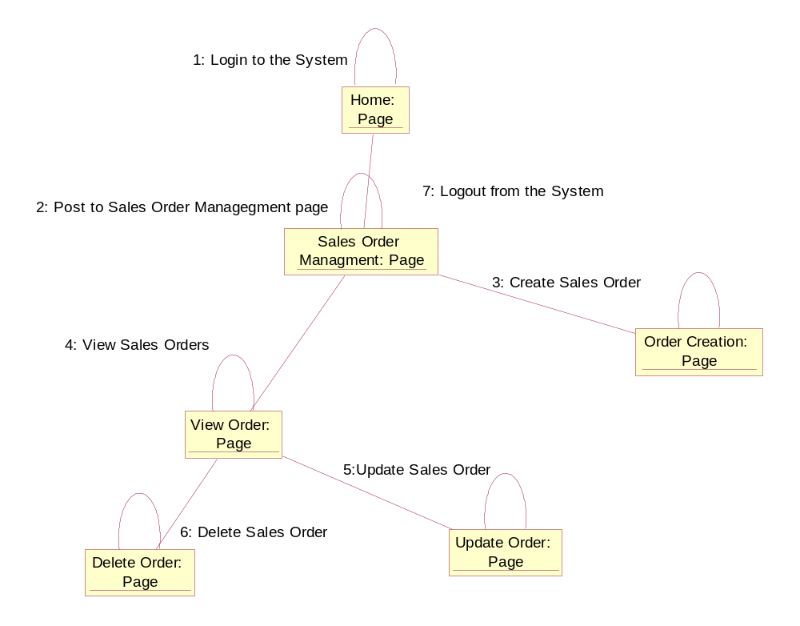

Participating Objects
: SalesStaff
The Sales Staff actor creates, views, update and delete Sales Orders.
: SalesOrder
Sales orders are created by Sales Staff. They can be viewed, updated and deleted.

: FormLogin
This Form lets the Sales Staff actor to:
- Login to the system.
:FormCreateSalesOrder
This Form lets the Sales Staff actor to:
- Create a new Sales Order
:FormViewSalesOrder
This Form lets the Sales Staff actor to:
- View all the Sales Orders
- From here the Sales Orders can be updated
- From here the Sales Orders can also be marked for deletion

Class Diagrams

Derived Requirements
A computer capable of running .Net and SQL Server programs is required to run this software.
A PC with key board, mouse and display.

